Bring CityMail

Description of the survey

Catinet and Bring Citymail have since 2008 been running a quality and distribution survey based on a panel recruited for this survey alone. The panel consists of approximately 1000 respondents and new members are recruited daily on the omnibus.
The general purpose of the project is to measure the quality of the distribution of different kind of postal magazines and commercials in relation to a few number of parameters.

This is a standard setup, where the same procedure is followed each time the client initiates a new survey. Data is collected in 3 different PQs.

Reference | PQ Name | PQ Name example
PQ1 | (project no and name) | 8412cit_5_Metro
PQ2 | (project no and name) nejsigere | 8412cit_5_Metro nejsigere
PQ3 | (project no and name) endelig rykker | 8412cit_5_Metro endelig rykker
PQ DATA | (project no and name) - DATA | 8412cit_5_Metro - DATA

Beside from the above PQs another one is used for notifying the panelists to be aware that a new distribution is about to take place. No data is gathered from this PQ.

Reference | PQ Name | PQ Name example
PQ4 | (project no and name) advisering | 8412cit_5_Metro advisering

Factual information

The project number is 8412cit and the extension changes from survey to survey. At Catinet the people involved are:

Ann-Kathrine Abildtrup Consultant
Anna Christensen Consultant while Ann-Kathrine is on maternity leave.
Nicolaj Christensen Data consultant
Nikolaj Voulfsbach Head of data department

The associated people at CityMail are:

Nis Gry-Jensen Project manager
Nis.Gry-Jensen@bringcitymail.com

Dorthe Bang Sortkjær Project assistant
Dorthe.Sortkjaer@bringcitymail.com

All data and information can be found on the production drive at: F:\Projekt\Citymail\Citymail Panel

The most important file is the one called:
20090806 NGNG Distributionsundersøgelser 2009 - plan og proces - til Catinet.xls

In this Excel sheet you will find the master time schedule and a specific overview of how the specific surveys are running. It is the responsibility of Bring Citymail to keep this file updated. The name of this file may of curse change along the way but the location should always be the same. Please find a thorough explanation of the use of this file in a later chapter.

Production process

In the Excel time schedule sheet please notice that every survey is marked with a different color. The columns are stating the dates and the rows are describing the task included. Sometimes two or three surveys are overlapping which shouldn’t however produce any problems. The data consultant at Catinet is to translate this schedule into English every time an update is received.

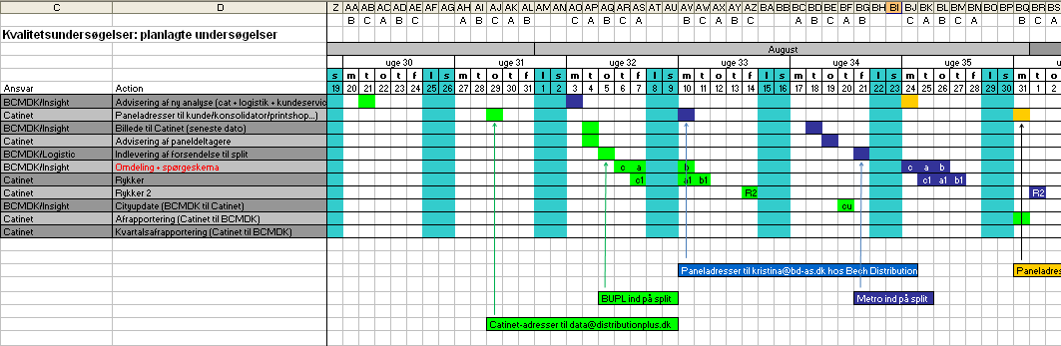

Another way of looking at the survey can be found in the below illustration. It focuses more on the given task to be done from a production point of view, rather than looking at the time schedule. The following manual will go through the process step by step based on these two illustrations.

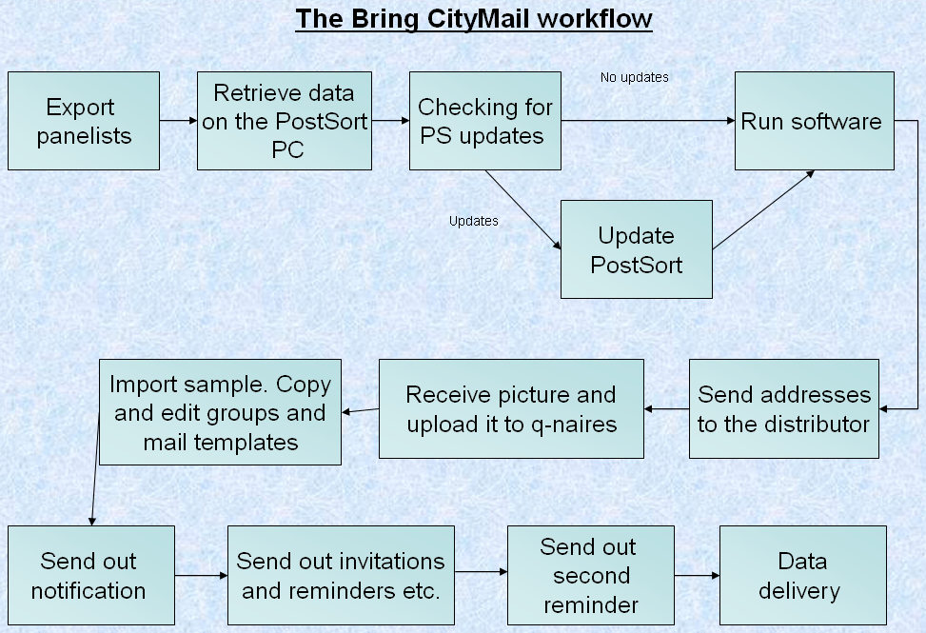

The first row in the time schedule does not involve any task to be done. It is only an information to Catinet that a new survey is about to begin.

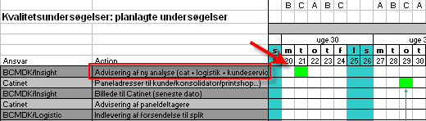

Export panelists and send the addresses

The first real step is the second row. At that time we are to send the addresses of the panelists to the given distributor that is involved for the current survey. For this particular example addresses are to be sent to data@distributionplus.dk.

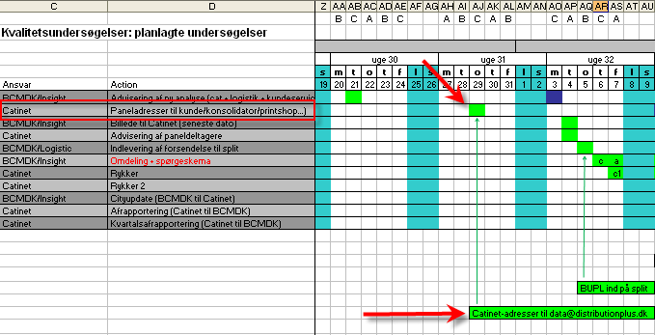

But in order to send the final addresses several actions needs to be done at the beginning. First we need to export the data from the panel questionnaires. The respondents are currently placed in the following three questionnaires:

7132cit Panel stamdata
7132cit - panel 2008 confirm (new recruits for 2008)
7132cit - panel 2009 confirm (new recruits for 2009)

Simply just export all successful completes. To find previous exports search for: 7132cit - panel 2009 confirm NIC and 7132cit Panel stamdata NIC. The first export job includes both of 2008 and 2009.

Create new folder in F:\Projekt\Citymail\Citymail Panel and call it 8412cit_xx_xxxx. Follow the current numbering and labeling. Create a subfolder called “sample” and save the exports in that folder. Paste relevant data from the two exports into a new excel sheet that only contain the following data in the following columns:

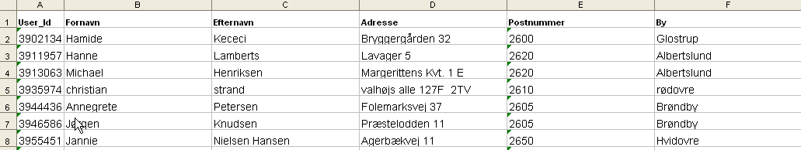

User_Id
Fornavn (First name)
Efternavn (Last name)
Adresse (Address)
Postnummer (Zip code)
By (City)

Just save it as “8412cit_xx_xxxx_Total sample”. There should be just over 1000 records. Send this file to your e-mail so that it is accessible from the PostSort Laptop, in case you should experience any problems connecting to the production drive from this laptop.

PostSort is a software that is only installed on a specific laptop currently placed in Catinet Copenhagen. There is a USB license key included the PC and software, so it has some natural limitations in relation to how and where to access. PostSort is used to convert Post Danmark zip codes into BringCtymail area zip codes, which are a bit different. Please see the attached document on how to use PostSort.

Before running PostSort please check for any updates of the software. Currently a notification of updates is send to Ulrik Hjarnaa and Nicolaj Christensen by mail, and it is possible to add more e-mail addresses to this notification mail group. If you need to update the software please follow the instructions in the notification mail.

The export from PostSort consists of two files. Only the file that has CMDK in the filename is relevant. Send this file to the e-mail address written in the Excel time schedule sheet for the given survey. It is very important to keep this deadline, and Catinet will be fined by Bring Citymail for late deliveries.

Receive picture from Bring Citymail

The next step is that CityMail is to send the picture for the given picture to Catinet.

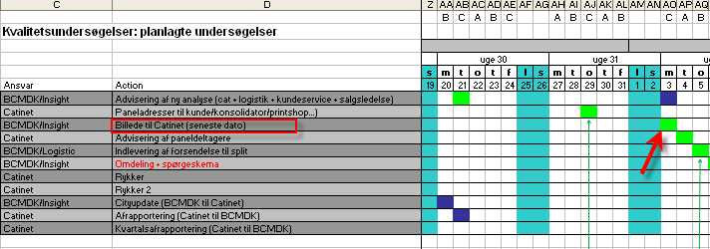

Often this picture is received in a PDF format so just convert it to jpg. by using SnagIt or any other photo tool. Create a subfolder in the current project folder and call it “Forside” (Picture) and place the picture here. For instance F:\Projekt\Citymail\Citymail Panel\8412cit_15_Metro\Forside.

Copy the four questionnaires from the previous survey.

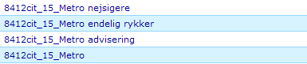

8412cit_xx_xxx which in this case is 8412cit_15_Metro is referred to as PQ1.

Upload the picture to the questionnaire templates and replace the old pictures with the new one in the questionnaires. Try to keep the same scales for width and height.

Import sample

The sample that was exported needs to be imported to CatGlobe. But first the CMDK text file is to be converted into an excel sheet according to certain standards. Basically the text file needs to go from looking like this:

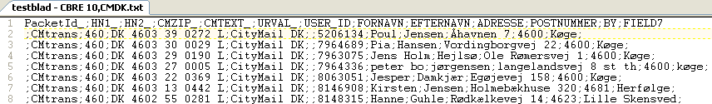

Into looking like this:

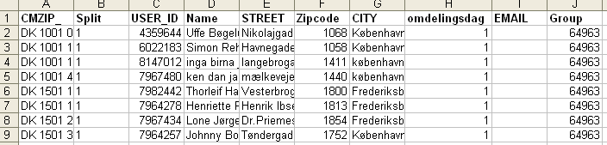

The text file is semi-colon delimited so use the “Import Data” function in excel and choose semi-colon as delimiter.

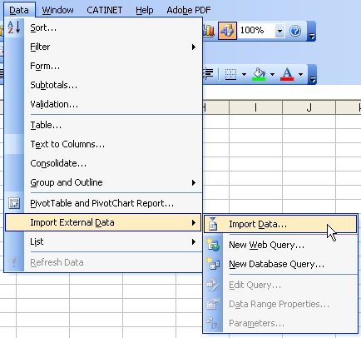

Delete redundant columns except from the ones shown in the above excel sheet. The two columns “Split” and “Omdelingsdag” are calculated based on the value in the CMZIP column. The value in the split column is actually just the same number as shown below.

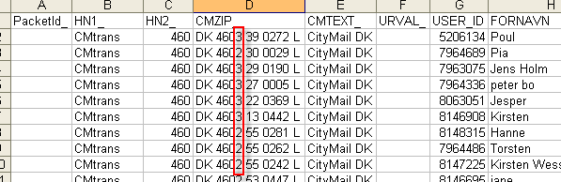

Just use the “Mid” function in excel to transfer that number into the Split column. Ex: =MID(D2;7;1). The value in the “Omdelingsdag” column refers to the value in the “Split” column. For the values 1 and 4, the value in the “omdelingsdag” column should be 1. For the values 2 and 5, the value in the “omdelingsdag” column should be 2. And for the values 3 and 6, the value in the “omdelingsdag” column should be 3.

The reason for doing so is to secure a representative sample. The panelist are then randomly distributed into groups that refers to the value in “omdelingsdag”. “Omdelingsdag” means the day that the respondent is to receive the postal material. Later on these days are just referred to as A, B and C days, instead of 1,2 and 3.

Create three groups and name them:
8412cit_xx_xxx Gruppe A
8412cit_xx_xxx Gruppe B
8412cit_xx_xxx Gruppe C.

Eg: 8412cit_15_Metro Gruppe A. For all the records that have a 1 in the “Omdelingsdag” column, type in the Group Id number for the group” 8412cit_xx_xxx Gruppe A” in the “Group” column. Continue this logic for the last two groups.

Now the sample is ready for import. Chose the User_Id column.
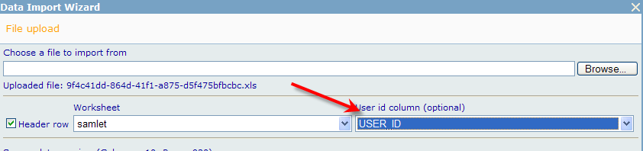

Choose the main questionnaire to import data to.
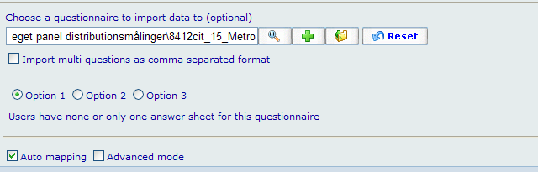

Make sure that “Omdelingsdag” is mapped to the right destination.

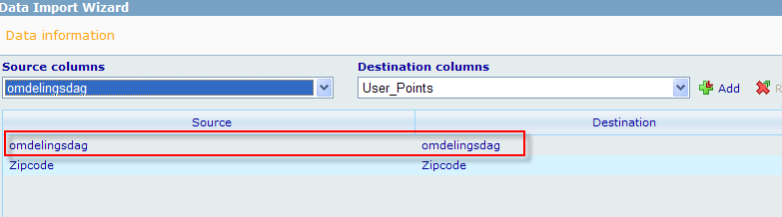

Import data. Check that the respondents have been imported to the created groups.

Copy and edit groups.

Find the groups from the previous survey and copy them and name them according to the new survey description.

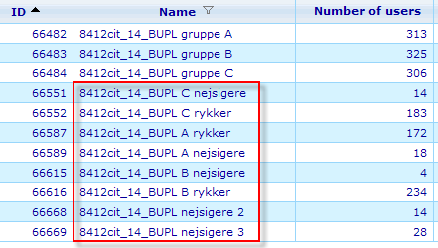

Change and update all the rules in the groups so that they refer to the new survey and not the old one. At this point there is no need for rebuilding the groups yet.

Copy and edit mail templates

Each of the four questionnaires has different mail templates attached. All of these should be copied respectively to the new PQ and relevant text and links are to be updated. Here are illustrations on how to do it.

Access the communicator module and “find and copy” the previous mail template. The one used for the main questionnaire is called …bulkmail.

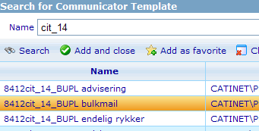

Change the link and the mail text that mention the specific survey material the following places:

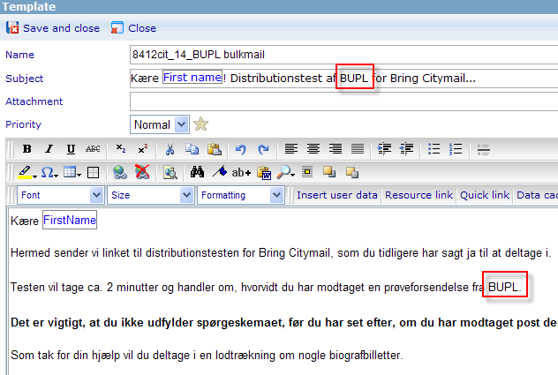
For some of the other mail templates this specific survey name may occur at other places and a few more times.

The correspondence between the questionnaires and mail templates are as follows:

Questionnaire | Mail template
8412cit_14_BUPL (PQ1) | 8412cit_14_BUPL bulkmail
8412cit_14_BUPL (PQ1) | 8412cit_14_BUPL rykker (reminder)
8412cit_14_BUPL nejsigere (PQ2) | 8412cit_14_BUPL nejsigere
8412cit_14_BUPL endelig rykker (PQ3) | 8412cit_14_BUPL endelig rykker
8412cit_14_BUPL advisering (PQ4) | 8412cit_14_BUPL advisering

Send out notification
With groups, mail templates and PQs created we are now ready for the mail notification.
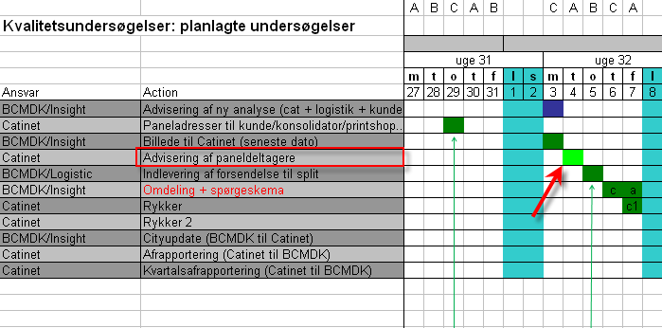

At that specific time we are to send a notification the panelists saying that are to pay notice to their mail box since they are to receive material according to the current distribution survey. It is only a notification and has no other purpose.

This notification mail is to be sent out at the given date between 16.00 and 17.00 Danish time. This is a general mail policy for this survey and therefore also applies for the other PQs and mail outs.

The notification is to be sent out to all respondents meaning the three groups that panelists were imported to.

